

[This Photo](https://www.pngall.com/christmas-hat-png/download/58723/) by Unknown Author is licensed under [CC BY-NC](https://creativecommons.org/licenses/by-nc/3.0/)

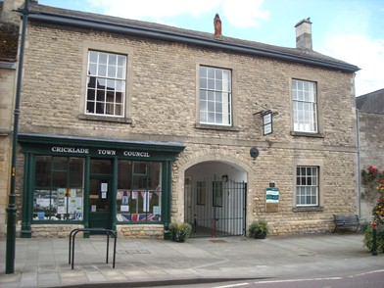

**From all of us here at Cricklade Surgery…**

Have a wonderful Christmas and a Happy New Year!





**CHRISTMAS OPENING TIMES 2024/2025**

Monday 23rd December: 8.30 – 18.30

Tuesday 24th December: 8.30 – 18.30

Wednesday 25th December: **Closed**

Thursday 26th December: **Closed**

Friday 27th December: 8.30 – 18.30

Monday 30th December: 8.30 – 18.30

Tuesday 31st December: 8.30 – 18.30

Wednesday 1st January: **Closed**

Open as normal from Thursday 2nd January



**ONLINE REGISTRATIONS**

Our surgery can now offer online registration for new patients wishing to register. They can either visit our website and click on new patients’ tab or use the address below to start the registration process.

[https://gp-registration.nhs.uk/J83609](https://gp-registration.nhs.uk/J83609%20)

**CARERS AND YOUNG CARERS**

Do you look after someone who is ill, frail, disabled or mentally ill? If so, you are a carer.

We are interested in identifying carers, especially those people who may be caring without help or support.

We support Young Carers – Do you know anyone or are you under the age of 18 caring for any of the above?

Please contact Reception to register as a carer or a young carer.

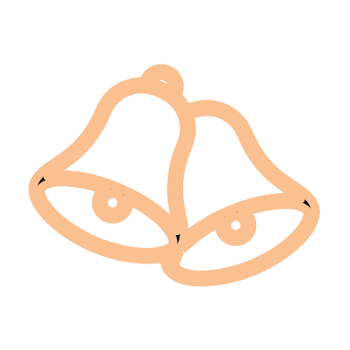

**CANCELLATION OF APPOINTMENTS**

Over the last few months, there has been a considerable increase in cancelled appointments at short notice. In September we had 28 patients that did not turn up, in October we had 35 and 29 in November.

Please make every effort to attend all appointments as we are unable to offer those to other patients.

If you do need to cancel an appointment, please give 24 hours’ notice.

**NEW MEMBERS OF STAFF**

We would like to introduce two new members of staff here at Cricklade Surgery.

Julie Dance in Reception and Kay Berry in Dispensary.

**PATIENT PARTICIPATION GROUP**

As a surgery we appreciate any feedback, and we ask for this in so many ways.

One way is in form of a group!

If you were to be a part of this, you would receive this newsletter along with a small questionnaire a couple of times a year.

We would like to hear from our patients in and around Cricklade.

Please call Reception to sign up today!



